**URDF Pelvis**

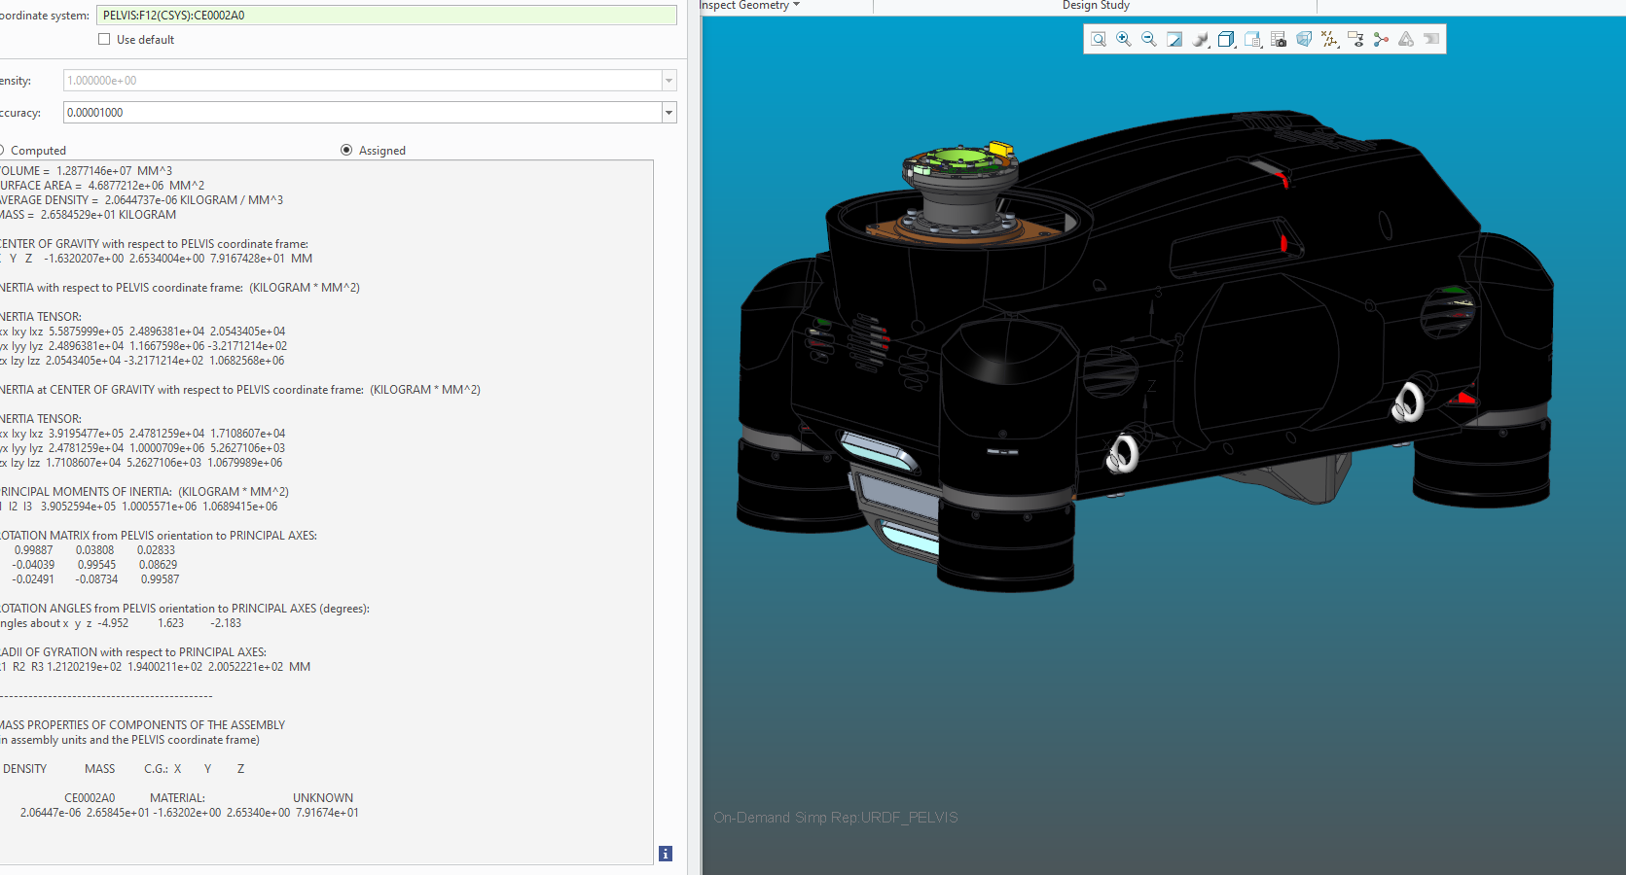VOLUME = 1.2877146e+07 MM^3

SURFACE AREA = 4.6877212e+06 MM^2

AVERAGE DENSITY = 2.0644737e-06 KILOGRAM / MM^3

MASS = 2.6584529e+01 KILOGRAM

CENTER OF GRAVITY with respect to PELVIS coordinate frame:

X Y Z -1.6320207e+00 2.6534004e+00 7.9167428e+01 MM

INERTIA with respect to PELVIS coordinate frame: (KILOGRAM * MM^2)

INERTIA TENSOR:

Ixx Ixy Ixz 5.5875999e+05 2.4896381e+04 2.0543405e+04

Iyx Iyy Iyz 2.4896381e+04 1.1667598e+06 -3.2171214e+02

Izx Izy Izz 2.0543405e+04 -3.2171214e+02 1.0682568e+06

INERTIA at CENTER OF GRAVITY with respect to PELVIS coordinate frame: (KILOGRAM * MM^2)

INERTIA TENSOR:

Ixx Ixy Ixz 3.9195477e+05 2.4781259e+04 1.7108607e+04

Iyx Iyy Iyz 2.4781259e+04 1.0000709e+06 5.2627106e+03

Izx Izy Izz 1.7108607e+04 5.2627106e+03 1.0679989e+06

PRINCIPAL MOMENTS OF INERTIA: (KILOGRAM * MM^2)

I1 I2 I3 3.9052594e+05 1.0005571e+06 1.0689415e+06

ROTATION MATRIX from PELVIS orientation to PRINCIPAL AXES:

0.99887 0.03808 0.02833

-0.04039 0.99545 0.08629

-0.02491 -0.08734 0.99587

ROTATION ANGLES from PELVIS orientation to PRINCIPAL AXES (degrees):

angles about x y z -4.952 1.623 -2.183

RADII OF GYRATION with respect to PRINCIPAL AXES:

R1 R2 R3 1.2120219e+02 1.9400211e+02 2.0052221e+02 MM

---------------------------------------------

MASS PROPERTIES OF COMPONENTS OF THE ASSEMBLY

(in assembly units and the PELVIS coordinate frame)

DENSITY MASS C.G.: X Y Z

CE0002A0 MATERIAL: UNKNOWN

2.06447e-06 2.65845e+01 -1.63202e+00 2.65340e+00 7.91674e+01